Week beginning June 22nd^{th}
Maths Challenge 4
Can you describe the 3d shapes in my model?
During the week, collect lots of empty boxes, packaging and cardboard.
Use your boxes and packaging to make a shape monster.
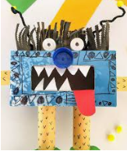
How can I describe my monster by the shapes she uses?
Monster part | Shape
legs | cylinders
body | cuboid
nose | cylinder
eyes | spheres
Now you try
Monster part | Shape

