Week beginning June 15th
Maths Challenge 4
Can you share these objects into equal groups?
It is harvest time and Farmer Connolly and Farmer Hamilton are sorting out their hay bales. They need them to be sorted into equal groups.
Who made equal groups?
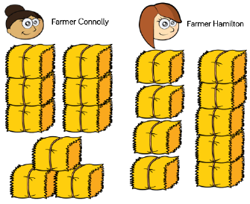
Farmer Connolly has groups of three bales. Farmer Hamilton has two groups, but one group has five bales and the other has 4 bales.
Can you group these bales into equal groups? You might want to use counters to help you.
- Can you group 12 bales into equal groups? Draw your groups.

- Can you group 16 bales into equal groups? Draw your groups.

