Week beginning June 29th
Maths Challenge 4
Is money in notes always worth more than money in coins?
Calculate the totals to find out which amount is worth more. 1 or 2?
Amount 1 | Amount 2
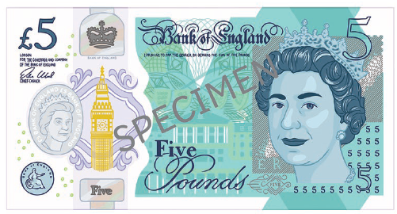 | 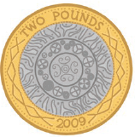

Amount 1 | Amount 2
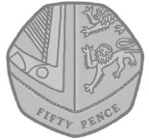

Amount 1 | Amount 2

Amount 1 | Amount 2

