Week beginning -8th June
Maths Challenge 4- How many in total?
Today we are going on a shopping trip! Here’s my shopping list
- 4 bunches of bananas
- 2 packs of cola
- 3 boxes of eggs

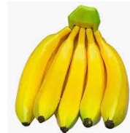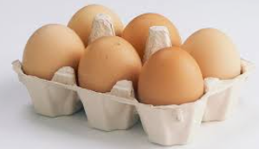

I can make an array to find out how many of each item I will be buying.
For example if I buy if I buy 2 packs of cakes

I can show that as an array-
6 cakes means 6 columns  2 packs means 2 rows |  | 12 cakes in total  6 + 6 = 12

How many in total- Shopping using arrays

- Can you use an array to work out how many bananas in total I’ll buy?
Complete the sentences | Make the array | Write a number sentence
__bananas means __columns  __bunches means __rows |  | __+__=__

- Can you use an array to work out how many cans of cola in total I’ll buy?
Complete the sentences | Make the array | Write a number sentence
__cans means __columns  __packs means __rows |  | __+__=__

- Can you use an array to work out how many eggs in total to buy?
Complete the sentences | Make the array | Write a number sentence
__eggs means __columns  __boxes means __rows |  | __+__=__

