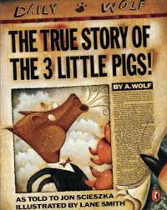
Friday 5th June
Writing Challenge
Listen to the story of The True Story of the Three Little Pigs
https://www.youtube.com/watch?v=m75aEhm-BYw
This is an alternative version of the Three Little Pigs and the wolf is portrayed as an innocent at the start of the story, which he (the wolf) insists is the true story.
For your writing challenge, I want you to convince me that the Wolf IS innocent and he is NOT a bad wolf. Listen to the story carefully and use the storyline to support your persuasive writing. In addition, a PDF document will help you write your persuasive argument.

Persuasive phrases
As a result…
This causes…
Another reason…
It goes without saying…
I strongly believe…
Is it really worth…
How could we possibly…

