Thursday 7th May 2020
Home Learning Tasks
Reading
Practise your VIPERS reading skills of sequencing and prediction.
- Watch episode 2 All Hail Macbeth! Thane of Cawdor! on https://www.bbc.co.uk/teach/school-radio/english-ks2-macbeth-index/zkxcbdm

- Read the cards and then arrange them in the correct order. (They are not in the correct order below).

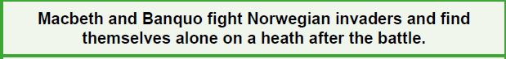
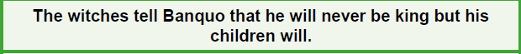
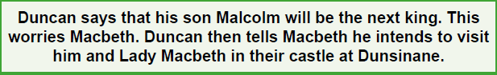
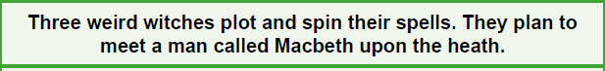
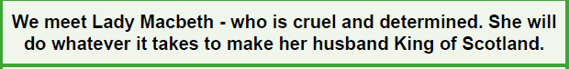
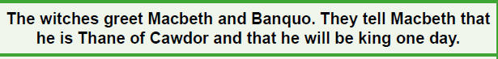
- Write your prediction for what you think will happen next.

Writing
Commas
- in lists
- joining sentences
- around embedded clauses
- with co-ordinating conjunctions
CGP books pages - find the pages in the contents page at the front of your book.
Answers are at the back of your book for you to tick and fix your work.

Maths
Subtracting decimals with a different number of decimal places
Questions and Answers (Tasks attached)

Answers for Reading Task
