Tuesday 30th June 2020
Spelling – ‘ph’ words
- Words to learn:
physical, sphere, pheasant, phrase, orphan, paragraph, phantom, geography, cellophane, pharaoh
- Give yourself a pre-test so you know which words you are already able to spell accurately and which ones you need to focus on. Remember to test yourself again after your learning.
- If you are unsure of the meaning of any of the above words, use a dictionary or Collins Online Dictionary https://www.collinsdictionary.com/ to help you find their definitions.
- Look at the words – What do you notice?
- They all include the digraph ‘ph’. How is this digraph pronounced?

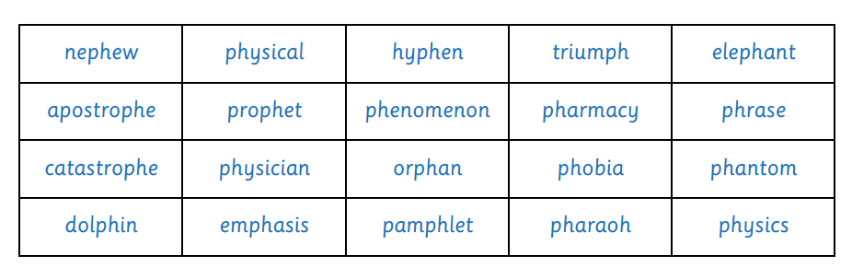
- Sorting Task – Look at the words below which contain the digraph ‘ph’. Sort the words into the columns below.

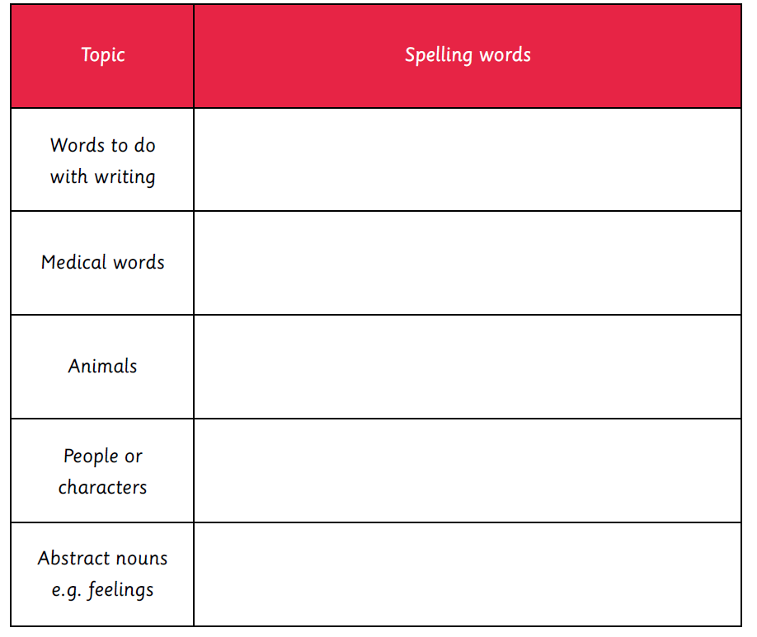

Answers
