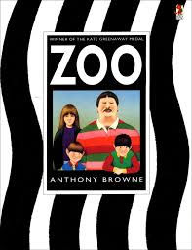
Zoo by Anthony Browne
Listen to the story Zoo online https://www.youtube.com/watch?v=T07u0AggVsg

Reading Comprehension

From the front cover, what you think the story is about?
…………………………………………….………………………………………….………………………………………….……………
…………………………………………….………………………………………….………………………………………….……………
…………………………………………….………………………………………….………………………………………….……………
Who are the main characters in the book?
…………………………………………….………………………………………….………………………………………….……………
…………………………………………….………………………………………….………………………………………….……………
How would you describe the characters?
…………………………………………….………………………………………….………………………………………….……………
…………………………………………….………………………………………….………………………………………….…………
…………………………………………….………………………………………….………………………………………….……………
…………………………………………….………………………………………….………………………………………….…………
…………………………………………….………………………………………….………………………………………….……………
…………………………………………….………………………………………….………………………………………….…………

Why was the beginning of the trip to the zoo so stressful?
…………………………………………….………………………………………….………………………………………….……………
…………………………………………….………………………………………….………………………………………….……………
…………………………………………….………………………………………….………………………………………….……………
…………………………………………….………………………………………….………………………………………….……………
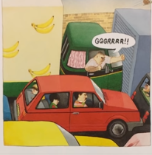

The family were stuck in a traffic jam. Look at the illustration carefully. What do you see? What interesting things did you notice?
Write key vocabulary or sentences.
…………………………………………….………………………………………….………………………………………….……………
…………………………………………….………………………………………….………………………………………….……………
…………………………………………….………………………………………….………………………………………….……………
…………………………………………….………………………………………….………………………………………….……………
…………………………………………….………………………………………….………………………………………….……………
…………………………………………….………………………………………….………………………………………….……………
…………………………………………….………………………………………….………………………………………….……………
The Animals at the Zoo
The author and his brother were not particularly interested in the animals at the zoo. Lunchtime was much more interesting.
What was your opinion about the animals at the zoo?
…………………………………………….………………………………………….………………………………………….……………
…………………………………………….………………………………………….………………………………………….……………
…………………………………………….………………………………………….………………………………………….……………
…………………………………………….………………………………………….………………………………………….……………
…………………………………………….………………………………………….………………………………………….……………

