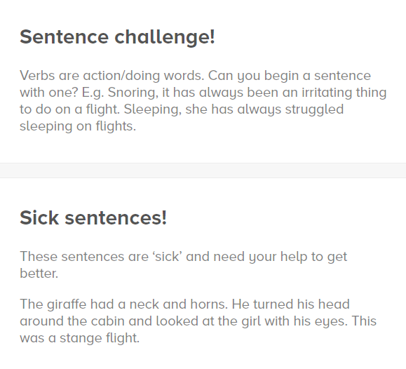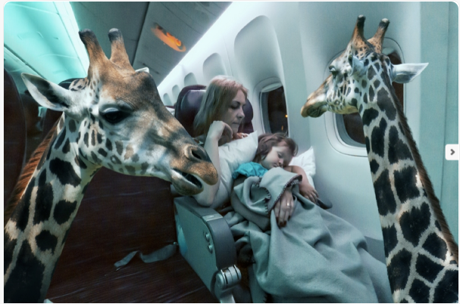

**Story starter!**

“Welcome to Animal Airlines: this is your Captain speaking! We will do everything we can to ensure you have an enjoyable and comfortable flight. Our highly trained crew will endeavour to meet your every need: the meerkats will provide in-flight entertainment, our koalas can bring you a variety of snacks, the sloths will take care of your luggage and the giraffes give excellent foot massages! For those of you wanting a good night’s sleep we have an excellent range of relaxing whale music available, or if it’s a party you’re after we have our in-flight music playing in the rear cabin, courtesy of ‘The Monkeys’. I once again do wish you a comfortable and enjoyable flight, and I can assure you that you can have every confidence in me as your Captain: everyone knows polar bears are extremely reliable!”

Can you continue this story about the flight on Animal Airlines?

You could try describing what each of the animals do during the flight, making up jobs for various different animals.