Choose a character from one of your reading books.
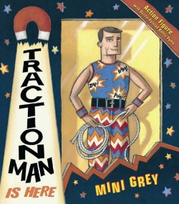
Write some sentences about the character using ‘and’ to join your ideas. Write a minimum of 5 sentences. Use information from the book to help you write your ideas.
For example, Traction Man likes to go on adventures and he likes helping out other people.

