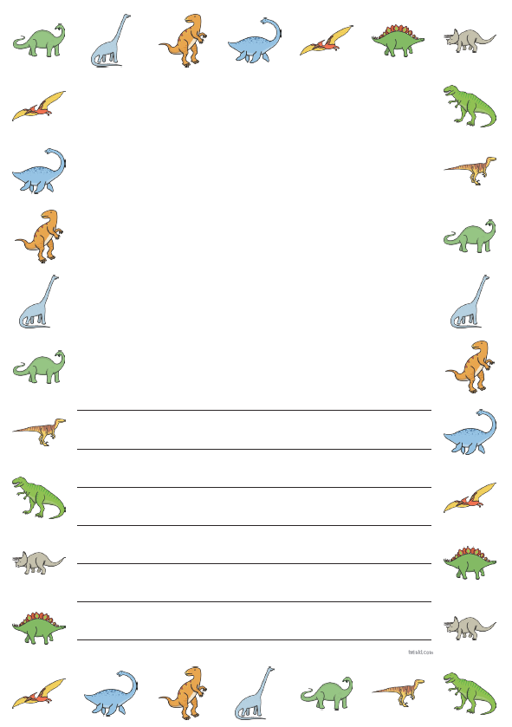

How are dinosaurs different to each other ?

Where do they live?

What is a dinosaur like?