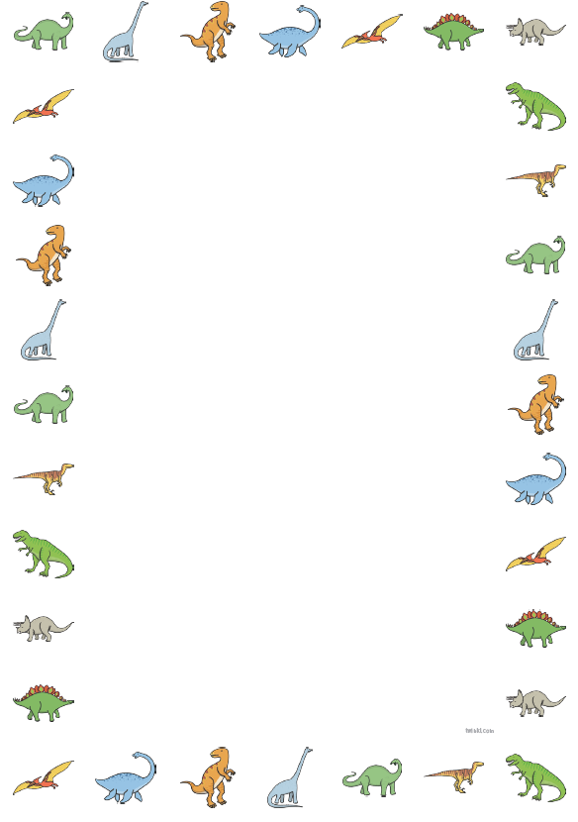

Head tail mouth spikes legs nails teeth plates

Dinosaur labelling

Choose one type of dinosaur and draw what it looks like.

Label each part of the dinosaur to show how it is different to other dinosaurs.