Dragon world

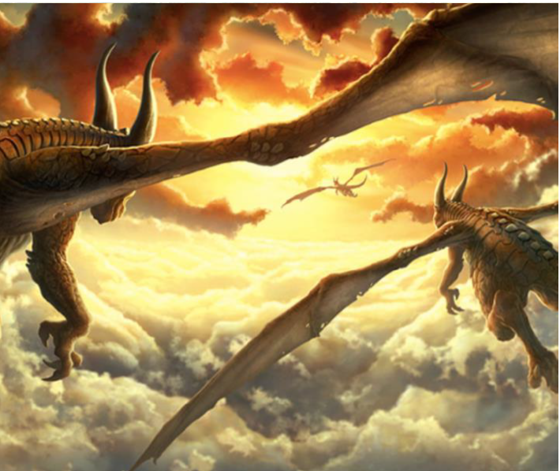

Story starter

This was their favourite time of day to fly.

As the glowing sun dipped below the horizon, night time began and the dragons could begin their flight.

The sky looked beautiful; full of pillow like clouds that the dragons gently touched with their wings as they flew through the still sky. The amber glow of the sun could still be seen in the distance. Thousands of scales that covered the beasts’ bodies glistened like diamonds in the dazzling sky.

As they reached full speed, leaving the world beneath them, they felt happy as they thought about where they were going. There would be others like them.

Can you continue the story?

|  |
| --- |
|  |
|  |
|  |
|  |
|  |
|  |