Dragon world

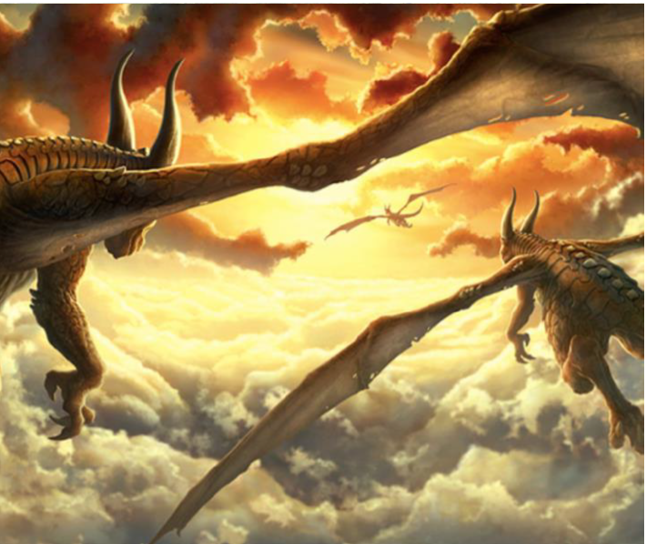

Look at the picture of the dragons with an adult. Discuss what you think of the picture and then have a go at answering the questions below.

Where are the dragons heading?

_____________________________________________________________________________________________________________________________________________________________________________________________

Are these the only three dragons that exist or are there some more?

_____________________________________________________________________________________________________________________________________________________________________________________________

Where have the dragons come from? Where is there home?

_____________________________________________________________________________________________________________________________________________________________________________________________

If you had a pet baby dragon how would you look after it?

_____________________________________________________________________________________________________________________________________________________________________________________________

Edit and improve

Can you improve these sentences? Try to think of some exciting adjectives you could use in each sentence. Check for capital letters, full stops and spelling mistakes too.

the dragon flew throoh the ski.___________________________________________________________________________________

There was clowds___________________________________________________________________________________________

The son was shinin in the Sky. _____________________________________________________________________________________

Story starter

This was their favourite time of day to fly.

As the glowing sun dipped below the horizon, night time began and the dragons could begin their flight.

The sky looked beautiful; full of pillow like clouds that the dragons gently touched with their wings as they flew through the still sky. The amber glow of the sun could still be seen in the distance. Thousands of scales that covered the beasts’ bodies glistened like diamonds in the dazzling sky.

As they reached full speed, leaving the world beneath them, they felt happy as they thought about where they were going. There would be others like them.