Kindness week
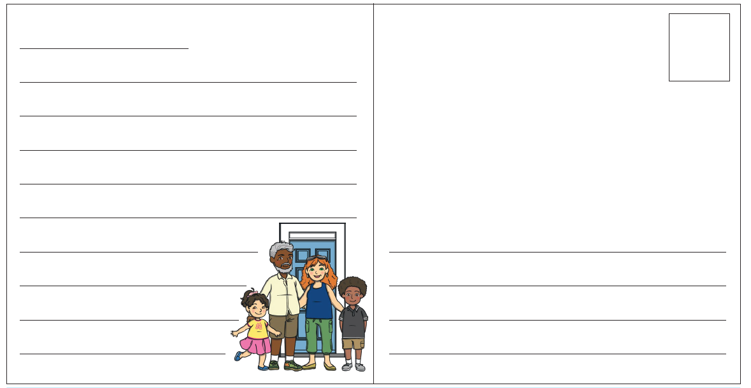
Write a postcard to someone you care about, to help brighten up their day. Tell them about what you have been doing and explain why you are missing them. On the back of the postcard draw a picture of something that you think will make them smile.

