|  |  |  |  |
| --- | --- | --- | --- |
| Number | Tens | Ones | Drawing |
|  |  |  |  |
|  |  |  |  |
|  |  |  |  |
|  |  |  |  |

[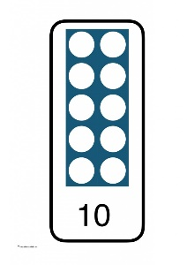](https://www.google.co.uk/url?sa=i&rct=j&q=&esrc=s&source=images&cd=&cad=rja&uact=8&ved=2ahUKEwi4iLHEirHdAhVJ1xoKHXb_DFEQjRx6BAgBEAU&url=https://www.pinterest.co.uk/pin/54887689189004878/&psig=AOvVaw14j5GcSiVSqYKVrw-qbvf4&ust=1536691081704737)[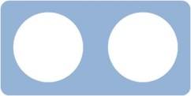](https://www.google.co.uk/url?sa=i&rct=j&q=&esrc=s&source=images&cd=&cad=rja&uact=8&ved=2ahUKEwijzPHfi7HdAhULUBoKHdWCDXMQjRx6BAgBEAU&url=https://www.easynotecards.com/notecard_set/50224&psig=AOvVaw0QtmUA-xyCvW5RNB8RP_pa&ust=1536691294435644)[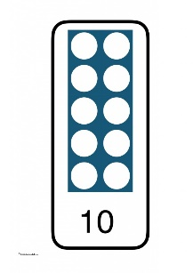](https://www.google.co.uk/url?sa=i&rct=j&q=&esrc=s&source=images&cd=&cad=rja&uact=8&ved=2ahUKEwi4iLHEirHdAhVJ1xoKHXb_DFEQjRx6BAgBEAU&url=https://www.pinterest.co.uk/pin/54887689189004878/&psig=AOvVaw14j5GcSiVSqYKVrw-qbvf4&ust=1536691081704737)

4

2

Tens Ones

**42**