Suffixes are a group of letters that are added onto the end of a ‘root’ word to change its meaning.
The suffixes ‘er’ and ‘est’ can be used to compare objectives, when added onto the end of adjectives.
For example
light

smallest
smaller
small
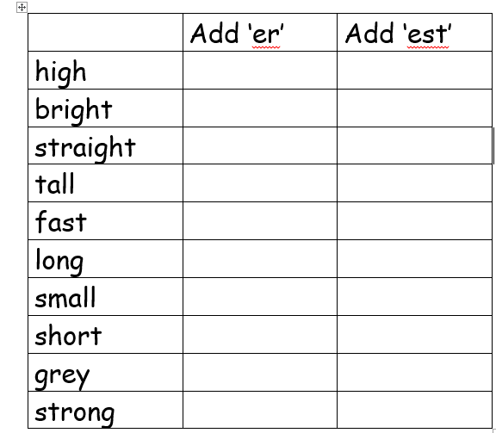
Complete the table below using the correct suffix
light
Can you find some objectives in your home/classroom and use adjectives to describe them? Then add either the suffix ‘er’ or ‘est’ to the end of each adjective to compare them.

