 | True | False
Superworm is long and strong.
Baby toad hopped onto a major road.
Superworm pushed baby toad out of the road.
Superworm made a fairground ride for the bees.
When beetle fell in the well, Superworm saved her by making himself into a fishing line.
Wizard Lizard’s servant was an ant.
Everyone was scared of servant crow.
Wizard Lizard had a magic flower.
Superworm found lots of treasure and sparkly gold.
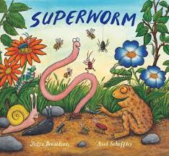
Superworm by Julia Donaldson

Put one tick next to each statement to show whether it is true or false.

